Speech Processing Walkthrough

Question 6:

**In your own words, why is this eﬀect known as ‘ring modulation’?**

Ring modulation is a form of amplitude modulation utilising two frequencies that move away from each other symmetrically by an interval of equal distance from the middle axis. The symmetry across the middle axis visually forms a ‘ring’, hence the name, ‘ring modulation’. **What does it sound like…**

Question 7:

**Why is SSB commonly used in long-distance radio voice communications?**

* Single Sideband – amplitude modulation
* SSB signals tend to propagate greater distances and exhibit more graceful degradation over distance than FM signals.
* [**https://hamradioschool.com/understanding-single-sideband-ssb-2/**](https://hamradioschool.com/understanding-single-sideband-ssb-2/)
* The narrower bandwidth of SSB has a couple of important implications:  1) The SSB signal consumes less of the available spectrum within an amateur band, thereby allowing more signals simultaneously on the band without interference; and 2) The power of a transmission is more densely applied in the narrower band, providing a higher average effective power across the transmitted band, and thereby giving the SSB signal more ‘punch’ than a comparably powered FM or AM signal in which the power is spread across a much broader range of frequencies.
* The trade-off with SSB as compared to conventional double-sideband AM and especially to FM phone mode is the quality of the audio. Narrower bandwidth dictates a reduction in audio information carried by the SSB signal as compared to the AM or FM signal. As a result, SSB audio will sound a bit thinner and less rich, but still quite intelligible and more than sufficient for weak signal phone communications.

 Single sideband modulation improves the efficiency of the transmission by removing some unnecessary elements. In the first instance, the carrier is removed - it can be re-introduced in the receiver, and secondly one sideband is removed - both sidebands are mirror images of one another and the carry the same information. This leaves only one sideband - hence the name Single SideBand / SSB.

While signals that use single sideband modulation are more efficient for two way radio communication and more effective than ordinary AM, they do require an increased level of complexity in the receiver. As SSB modulation has the carrier removed, this needs to be re-introduced in the receiver to be able to reconstitute the original audio.

**SSB advantages**

Single sideband modulation is often compared to AM, of which it is a derivative. It has several advantages for two way radio communication that more than outweigh the additional complexity required in the SSB receiver and SSB transmitter required for its reception and transmission.

1. As the carrier is not transmitted, this enables a 50% reduction in transmitter power level for the same level of information carrying signal. [NB for an AM transmission using 100% modulation, half of the power is used in the carrier and a total of half the power in the two sideband - each sideband has a quarter of the power.]
2. As only one sideband is transmitted there is a further reduction in transmitter power.
3. As only one sideband is transmitted the receiver bandwidth can be reduced by half. This improves the signal to noise ratio by a factor of two, i.e. 3 dB, because the narrower bandwidth used will allow through less noise and interference.

The summary of this is that SSB modulation offers a far more effective solution for two way radio communication because it provides a significant improvement in efficiency.

Question 8:

**COM3502-4502-6502: Why can the voice be shifted up in frequency much further than it can be shifted down in frequency before it becomes severely distorted? /emphHint: look at [wsprobe∼].**

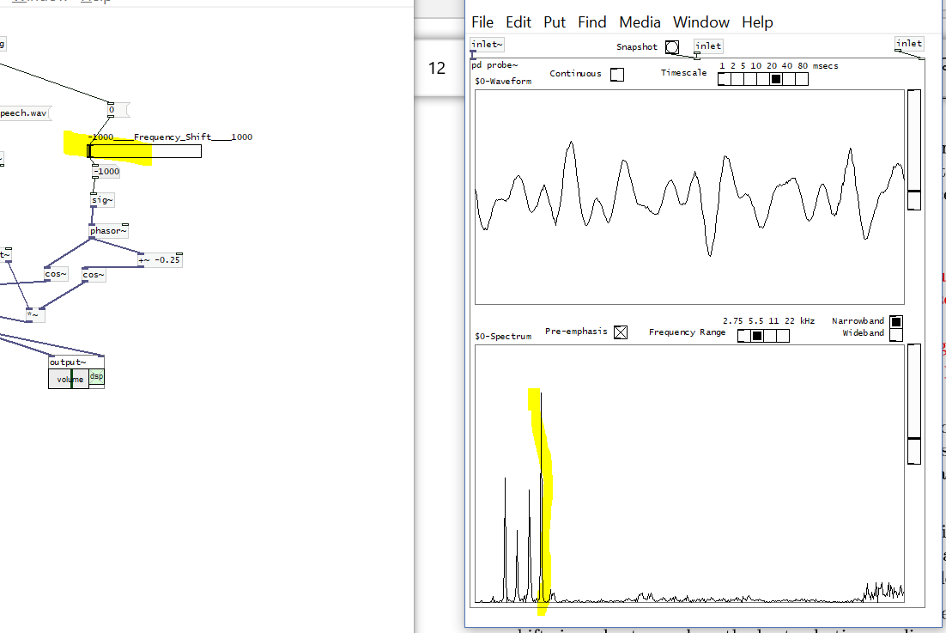

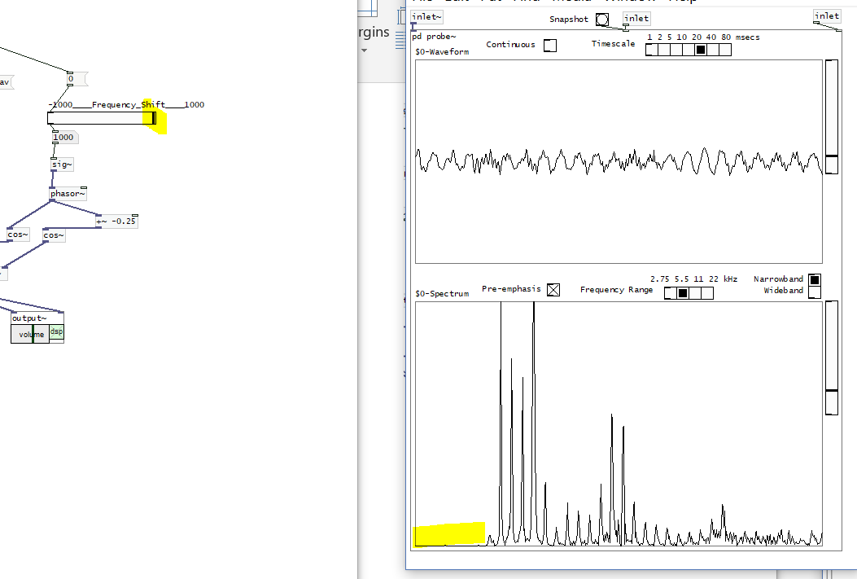- formants – the f0 formant is the furthest to the left – and is not distorted by tones underneath it.

Whereas, the highest formant

Shifting up the frequency pushes the formant to the right of wsprobe. – we lose some of the highest noise

Question 9:

**In a practical system, why is it important to keep the feedback gain less than 1?**

* can only hear crackle